Potentially Visible Sets (PVS) & Portals

Go to the module (CO3303) page. Download the files from materials page. Extract the contents of the zip file to a work folder and open the Visual Studio project ‘Portals.sln’.
The project is a similar to earlier entity-based projects – it loads and displays a simple house and some car entities. The house has been split into partitions with doors and windows acting as portals between the partitions. We are not concerned with the cars for this exercise.
- Run the program and explore the house
- Note the frame time when moving round the rooms
The layout of the house is given below:
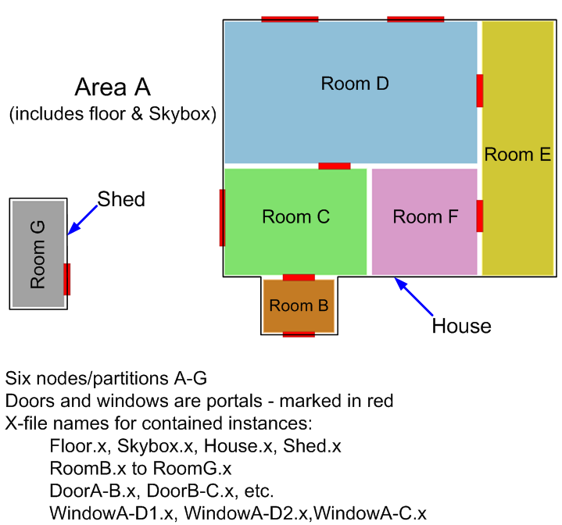

Partition / PVS Usage
At first the program is not making use of the partitions. All the entities are placed in partition A (number 0 in the code) in the SceneSetup function. The function RenderScene assumes partition A is the location of the camera and everything in the partition is rendered. The first task will be to get a simple PVS system working – the partitions need to be correctly populated, then each one given a list of other potentially visible partitions.

- First put all the entities in their appropriate partitions in the SceneSetup function. The partitions labelled A-G above are numbered 0-6 in the code. Consider that some entities may belong in more that one partition.

- Now run the program - only partition A (0) entities should be rendered – everything in the outside world, but not the rooms in the house.
- Change RenderScene so that it renders the contents of the camera's partition rather than partition 0. Use the function GetPartitionFromPt to help find the camera's partition

- Run the program and move into the house and around the rooms. The rooms should switch on as you enter them, but only the current partition will be drawn.

In this program the partitions are all cuboids so finding the camera's partition is straightforward. With more complex, arbitrary partitions this can be trickier - one possible approach is to use an octree to locate the camera. Portal-related systems need this step, and it is one of their drawbacks.

Now we add a Potentially Visible Set (PVS) to each partition. This is the set of other partitions that can be seen from a partition from some camera position

- Find the section marked Partition data and the Partitions array. Note that there are entries for PVS, but they are empty

- Enter the PVS lists for each partition. For example if you think that partition 0 can only potentially see two partitions 3 & 5, then enter 2, {3,5} instead of the current empty lists (0, {}). Use the diagram above to help

- Now add code to RenderScene at the point marked Render PVS here to through the start partition's PVS list, rendering each partition in it

- The house should now be drawn correctly again. A list of the partitions currently being rendered appears in the top left. There should be some areas in the house where only a couple of partitions are rendered

- Be sure that that no visible partitions disappear when visible through several doors / windows

The PVS is effective and simple to implement, but it is very conservative and does not remove many non-visible partitions. Now we will look at portals as a more aggressive technique to cull unseen areas.

Portals
The doors and windows in the house have been entered as a set of portals in the Partitions and PortalPolys arrays. The portals were derived manually from polygons in the artwork, which is a common process. Automatic portal generation is possible but difficult, and usually has limitations.

- Comment out the code you added to render the PVS list – the portal system can work without using it. Leave the line to render the starting partition though

- Fill in the missing sections in the RenderPortals code

- At the point marked Render Portals here add a call to RenderPortals. The screen area to use (the min/max parameters) should be the whole viewport, use the ViewportWidth and ViewportHeight global variables for this

- Now the program should draw many fewer partitions, particularly inside the house. Fly under the ground and look up – you can see exactly which partitions are switching on and off

- There are some issues:
  - Errors when close to the portals (a flicker as you pass through each door)
  - Occasional disappearance of visible areas when looking through the two windows in partition D
    - Any other problems are probably due to errors in your additions
  - What is causing these two issues? How could they be fixed?

Advanced Portal Usage
Go to the module (CO3303) page. Download the Portals2 project file for Lab week 9 from the materials page. Extract the contents of the zip file to a work folder and open the Visual Studio project ‘Portals2.sln’.
The project extends the previous one, but with a considerably more advanced portal system. Now portals can be added at runtime using the function AddPortal. Portals can take different shapes and can be added anywhere, regardless of geometry. If placed on a wall or in mid-air, they will create a hole that leads to the portal target. More importantly, portals can now have a separate entrance and exit polygon, which do not have to be in the same place, or even have the same orientation or size. Travelling through such a portal “teleports” the camera between the disparate portal locations.

- The standard set of portals has been added to the house, together with a new one in a wall. Run the program to see the new addition (note the portal flicker remains)
- Portals are added in the function SceneSetup in the “Portal Setup” section. Move the exit portal to the right by a couple of units to see how these portal types work
- Add a portal joining the shed to room E. Experiment to get the right positions
- Add a couple more portals of your own choosing. Maybe create one that has an entrance and exit at different rotations. Or perhaps a portal whose exit faces its entrance at either end of a corridor
The core portal system code is as the previous exercise – portal vertices are mapped to pixel coordinates, if they are on screen then the portal is followed to the connecting partition.
The main change is the splitting of each portal into two polygons, each positioned with a separate world matrix. When rendering through such a portal, a matrix transform is applied to the camera so the scene viewed through the portal is the correct one for the exit portal. The teleporting of the camera uses the same matrix transform.
There is some complexity in the rendering - if performed naively, the transformation of the camera would cause many visual errors. To do it properly requires techniques similar to the stencil mirrors from the 2nd year graphics module.
- Investigate the new code to find the range of changes required
Extend the code so further portals can be added more flexibly:
- Update the AddPortal function so portals can be created rotated in X,Y and Z rather than just around the Y axis
and / or
- Add new code so that portals can be added in front of the camera by pressing keys:
  - Press F1 to set the entrance portal position
  - Press F2 to set the exit portal position
  - Press F3-F6 to create a portal joining the entrance to exit, each key with a different portal shape

